Task Description#1

* Generate python code that performs sorting of list using both the bubble sort algorithm and pythons built in sort() function compare the two implementations.

Expected output#1

* Two sorting implementations :

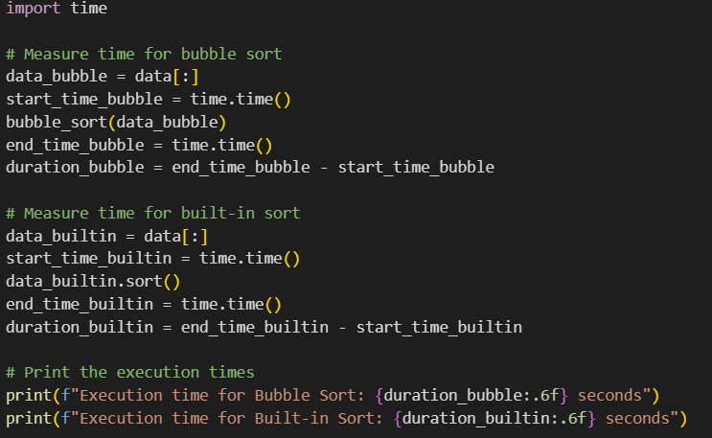

**OUTPUT**:

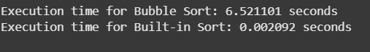

Task Description#2

* In colab ,use google gemini to generate a python function that takes a string and returns: the number of vowels the number of constrants , the number of digits In the string

Expected output#2

Complete function that iterates through characters of a string and counts vowels,consonats,and digits.

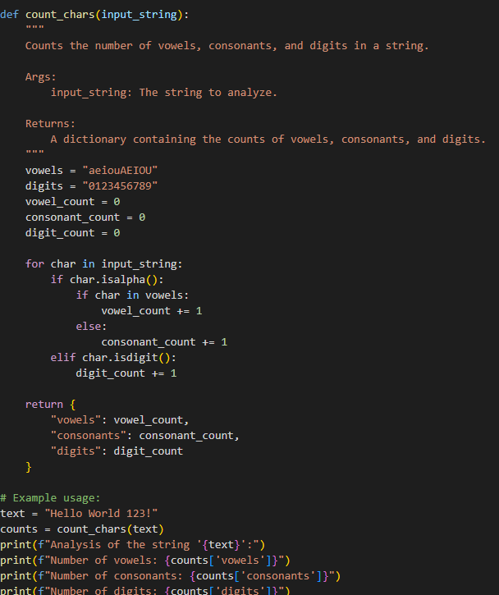

**OUTPUT**:

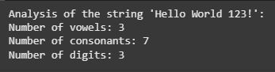

Task Description#3

* Use gemini to generate a python program that performs file handling
* Create a text file
* Write sample text
* Read and display the content

Expected output#3

Functional code that creates a.txt file,writes content to it,and reads it back.

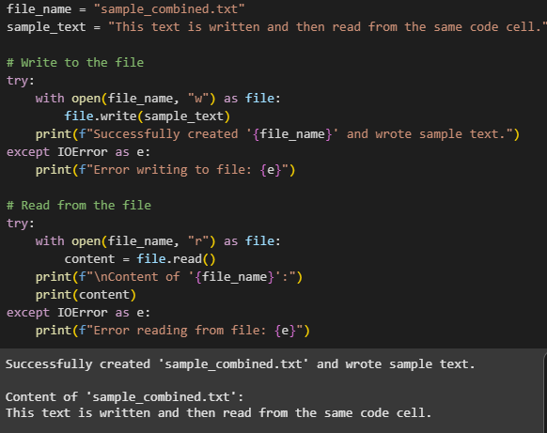

Task description#4

* Ask Google Gemini to generate a python program that implements a simple calculator using functions (add,subtract,multiply,divide). Then ,ask Gemini to explalin how the code works.

Expected output#4

* Complete calculator code with user input and operation selection,
* Line by line explanation or markdown style explanation provided by gemini.
* Screenshot the both the code and explanation in colab.

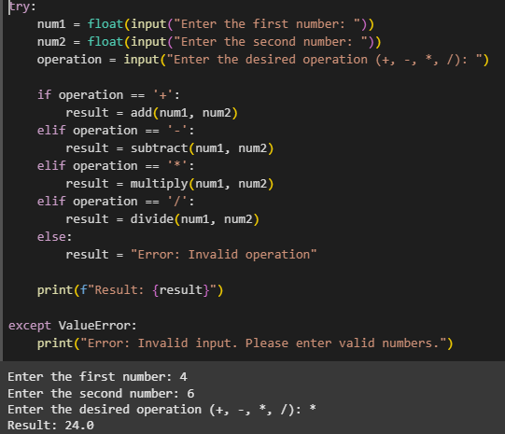

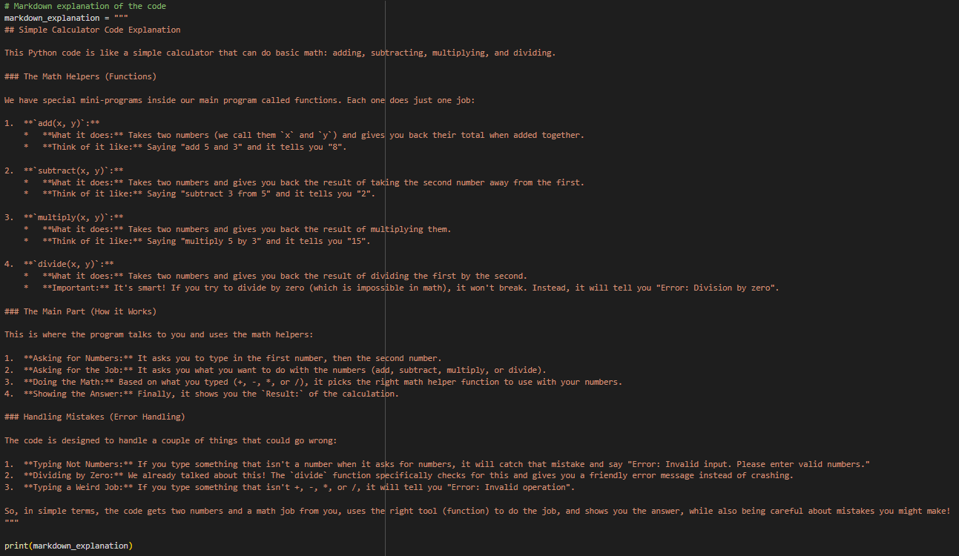

Task Description#5

* Use gemini to create a python program that checks if a given year is a leap year or not .try different prompt styles and see how gemini modifies its code suggestions.

Expected output#5

* A functional program to check a leap year with sample input/output
* At least two versions of the code from different prompts
* A short comparision of which version is better and why

